[Organisation Logo]
[Organisation Name]

CYBER INCIDENT RESPONSE PLAN

Version: | [Version Number]
Date of version: | [Date]
Created by: | [Name]
Approved by: | [Name]
Confidentiality level: | [Confidentiality Level]

Change history
Date | Version | Created by | Description of change
18/04/2023 | 0.1 | Joe Bloggs | Initial Release
01/05/2023 | 0.2 | Jane Smith | Managing records updated

Table of Contents
1. Purpose, scope and users 4
2. References & Further Reading 4
3. Incident Response Process 5
3.1. Communications and Documentation 5
3.2. Clarity is Critical 5
4. Cyber Security Incident Response Team (CSIRT) 6
4.1. Structure and Membership 6
5. Key Contacts 8
5.1. CSIRT Team: 8
5.2. External Contacts: 8
6. Authorisations in a Crisis 8
7. Critical IT Systems 9
8. Severity Classification and Escalation Criteria 10
8.1. Severity Classification 10
8.2. Escalation Criteria 12
8.2.1. Severity - Informational 12
8.2.2. Severity - Low 12
8.2.3. Severity - Medium 12
8.2.4. Severity - High 13
8.2.5. Severity - Critical 13
8.3. Learning from incidents 13
8.4. Disciplinary actions 13
8.5. Collection of evidence 14
9. Legal and Regulatory Requirements 15
9.1. Collection of Evidence 15
9.2. The GDPR 15
9.2.1. Breach Notification 15
9.2.2. Appropriate Technical and Organisational Measures 15
9.3. Contractual Obligations 15
10. Checklists 17
10.1. Severity - Informational 17
10.2. Severity - Low 17
10.3. Severity - Medium 17
10.4. Severity - High 17
10.5. Severity - Critical 18
11. Validity and Document Management 19
Appendix 20
A. Cyber Incident Response Playbooks 20
i. Ransomware 20
ii. Phishing 25

Purpose, scope and users
The purpose of this document is:
- To ensure quick detection of cyber security events and weaknesses, and quick reaction and response to cyber security incidents
- To identify key personnel to be contacted in the event of a major cyber security incident
- To provide details of the incident management process and escalation procedures
- To minimise the adverse impact on the business caused by a cyber security incident
This document is applied to the entire organisation, i.e. to all employees and other assets within [Organisation Name], as well as to suppliers and other persons outside the organisation who come into contact with systems and information within [Organisation Name].
Users of this document are all employees of [Organisation Name], as well as all abovementioned persons.

References & Further Reading
- National Cyber Security Centre
- CIS Controls
- NIST

Incident Response Process
Figure 1: Incident Response Process Example provides an example of a high level incident response process, with guidance notes in red.
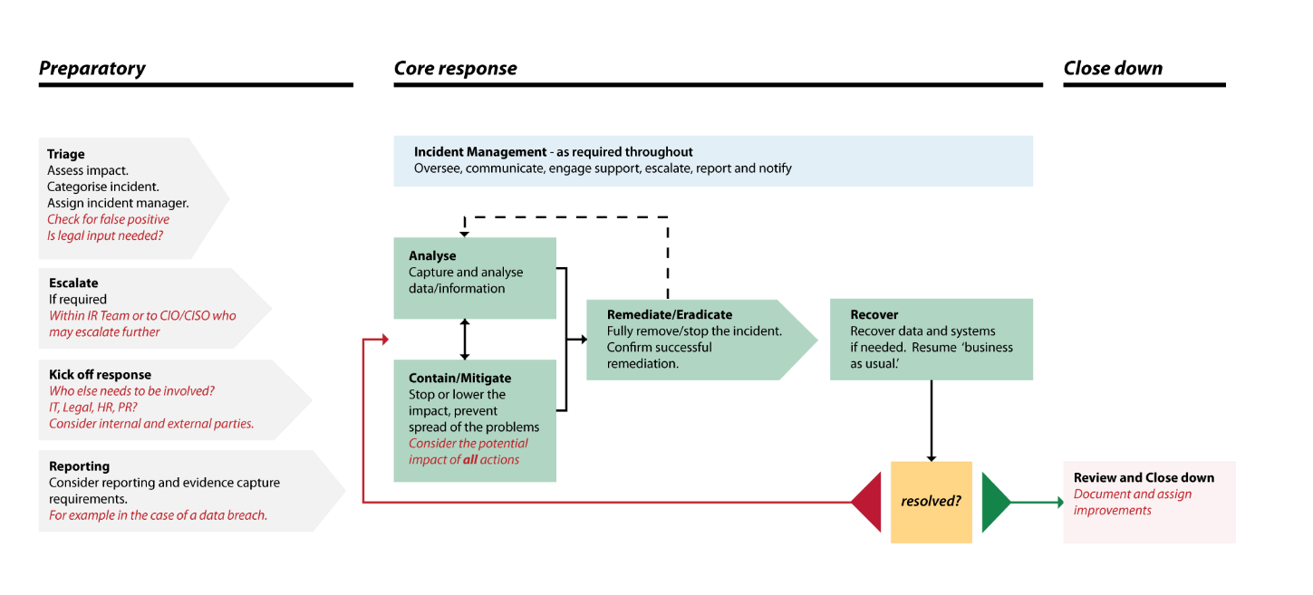
Figure 1: Incident Response Process Example

Communications and Documentation
Clarity of communications and accurate documentation are essential parts of Incident Response. The following activities are essential to a successful Incident Response:
- Tracking, documenting, assigning and correlating all findings, tasks and communications.
  - Note that keeping careful track of the whole response is very important in cases which may later be reviewed by regulators or courts. This includes real or potential data breaches and criminal activity
- Arranging of regular update meetings or calls, and involvement of relevant teams
  - This may be done over the Conference Bridge where regular updates are given
- Ensuring the incident is communicated and escalated appropriately
  - To the Cyber Security Incident Response Team (CSIRT), Senior Management, wider business, other stakeholders (e.g. Shareholders, DPO, etc.)
- Ensuring that the full incident lifecycle is covered
  - From initial discovery through to close down.

Clarity is Critical
Understanding everyone's roles and responsibilities is central to ensuring an incident is managed, and therefore handled, successfully.
There must be a central point of co-ordination, no matter who is involved, to ensure all findings are correlated and actions are planned (In the case of High and Critical incidents, see 4. Cyber Security Incident Response Team (CSIRT)).
Keeping a careful record of the incident response, decisions made, actions taken, data captured (or missing) is incredibly important for post-incident reviews. This is especially true if you will need to present evidence of your response to a regulatory body.

Cyber Security Incident Response Team (CSIRT)
A cyber security incident response team (CSIRT) consists of the people who will handle the response to an incident. It may include both internal and external teams and may differ based on the nature of the incident. Generally, the CSIRT will only be invoked for High and Critical incidents.
The core team will be IT or Cyber Security staff. The extended team may include other capabilities, such as PR, HR and legal, depending on the incident and response required.
The team is not intended to be dedicated to Incident Response full time. They are pulled together when needed to effectively respond to incidents.

Structure and Membership
The Cyber Security Incident Response Team (CSIRT) may require a number of roles in order to ensure that incidents are managed and coordinated effectively.
These fall under the headings:
- Government and law enforcement
- Senior / Executive management
- Incident manager
- Technical lead / recovery manager / recovery lead
- Crisis management, business continuity, disaster recovery
- Investigators and analysts, cyber security specialists
- IT and infrastructure
- Other departments including legal, PR, HR and customer services
Figure 2: CSIRT Structure & Membership details the core roles which will be needed during an incident.
Some individuals may perform more than one role but the responsibilities must be accounted and available as needed, if an incident is to be handled smoothly.
Optional roles are listed, pulling in external teams and additional business management functions.
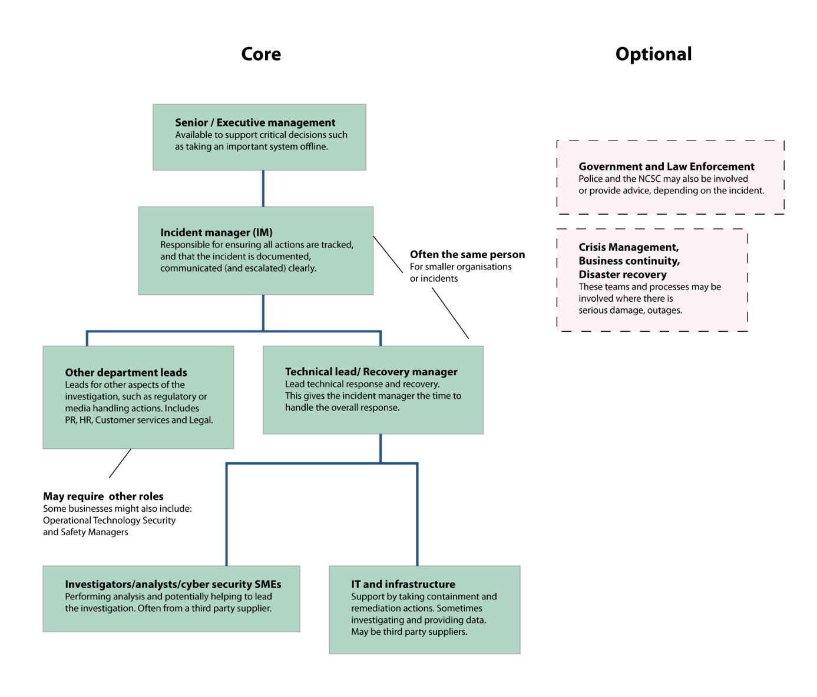
Figure 2: CSIRT Structure & Membership

Key Contacts

CSIRT Team:
No. | Role in Recovery | Name | Job title / Organisational Unit | Mobile phone | Landline phone | E-mail | Home address | Name of substitute
1. | Conference Bridge | Conference Bridge | N/A | <NUMBER> | <NUMBER> | N/A | N/A | N/A
2. | Technical/Recovery Lead | <NAME> | CTO | <NUMBER> | <NUMBER> | <EMAIL> | <ADDRESS> | <NAME>
3. | Technical/Recovery 2nd | <NAME> | CIO | <NUMBER> | <NUMBER> | <EMAIL> | <ADDRESS> | <NAME>
4. | System Admin | <NAME> | Head of Support | <NUMBER> | <NUMBER> | <EMAIL> | <ADDRESS> | <NAME>
5.
6.
7.

External Contacts:
No. | Name of organisation | Name | Job title / organisational unit | Mobile phone | Landline phone | E-mail | No. of substitute
1. | <DATA CENTRE> | NOC | NOC | <NUMBER> | <NUMBER> | <EMAIL> | <NAME>
2. | <3PP> | Support | Support | <NUMBER> | <NUMBER> | <EMAIL> | <NAME>
3. | <3PP> | Support | Support | <NUMBER> | <NUMBER> | <EMAIL> | <NAME>
4. | <3PP> | Support | Support | <NUMBER> | <NUMBER> | <EMAIL> | <NAME>
5. | Fire Brigade | Emergency | N/A | 999 or  112 | <NUMBER> | N/A | N/A
6. | PR Company | <NAME> | <TITLE> | <NUMBER> | <NUMBER> | <EMAIL> | <NAME>
7. | ESB | Support | Support | <NUMBER> | <NUMBER> | https://www.esb.ie/esb-networks/powercheck/ | N/A
8. | Broadband Provider | Support | Support | <NUMBER> | <NUMBER> | <EMAIL> | N/A
9. | An Garda Síochána | Emergency | N/A | 999 or 112 | <NUMBER> | N/A | N/A
10 | Cyber Insurance | <NAME> | <TITLE> | <NUMBER> | <NUMBER> | <EMAIL> | <NAME>

Authorisations in a Crisis
Role in Recovery / Job Title | Authorisations
CIO / CTO | Authorised to take all steps specified in this Cyber Incident Response Plan in order to recover the IT infrastructure / IT services
CIO | Authorised for urgent purchases of equipment/services up to €2,500
Business Development Managers | Authorised to communicate with clients
CTO | Authorised to cooperate with Data Centre

Note: only the CEO is authorised to communicate with the public through public media

Critical IT Systems
Application | Accessed By: | Vendor | Contact Name | Mobile Phone | Email
<APPLICATION NAME> | <NAME> | <NAME> | <NAME> | <NUMBER> | <EMAIL>
<APPLICATION NAME> | <NAME> | <NAME> | <NAME> | <NUMBER> | <EMAIL>
<APPLICATION NAME> | <NAME> | <NAME> | <NAME> | <NUMBER> | <EMAIL>
<APPLICATION NAME> | <NAME> | <NAME> | <NAME> | <NUMBER> | <EMAIL>
<APPLICATION NAME> | <NAME> | <NAME> | <NAME> | <NUMBER> | <EMAIL>

Severity Classification and Escalation Criteria
Each employee, supplier or other third party who is in contact with information and/or systems of [Organisation Name] must report any system weakness, incident or event which could lead to a possible cyber security incident in the following way:
- all information and communication technology-related events must be reported to the [Job Title]
- all other events must be reported to the [Job Title]
Incidents, weaknesses and events must be reported as soon as possible, by phone or in person and logged in [Organisation Name] ticketing system.

Severity Classification
The person who received the information must refer it to the [Job Title] for classification. When considering how to classify events/incidents, the CIA Triad must be taken into account:
- Confidentiality
  - Has sensitive data been accessed, leaked or stolen?
- Integrity
  - Could data or systems have been altered such that they cannot be trusted?
- Availability
  - Is the availability of data or systems impacted (i.e. what is the impact on the business output?)?
In addition to the above, consideration should be given to the scale of the problem, to what type of system or data is involved, and the practical consequences of the incident.
Events are classified in the following way:
Severity | Definition | Examples
Critical | An incident which can incur significant and extreme damage due to loss of confidentiality or integrity of information, or may cause an interruption in the availability of information and/or processes for an unacceptable period of time. Production Hardware or Software not operational | - Over 30% of staff (or several critical staff/teams) unable to work  - Critical systems offline with no known resolution  - High risk to / definite breach of sensitive client or personal data  - Financial impact of €???  - Severe reputational damage - likely to impact business long term
High | An incident which can incur significant and damage due to loss of confidentiality or integrity of information, or may cause an interruption in the availability of information and/or processes for an period of time. Production Hardware or Software only partially or not operational | - Over 10% of staff (or several critical staff/teams) unable to work  - Non-critical systems affected and/or critical systems affected with a known (reasonable) time to resolution  - Risk of breach of sensitive client or personal data  - Financial impact of €???  - Potentially serious reputational damage - likely to impact business medium term
Medium | An incident which cannot significantly impact confidentiality or integrity of information, and cannot cause long-term unavailability. Production Hardware or Software operational, but possibly impaired in some way | - Only a small number of staff/teams, or potentially no staff, unable to work  - Small number of non-critical systems affected with a known (reasonable) time to resolution  - Potential risk of breach of small amounts of non-sensitive data  - Financial impact of €???  - Low risk of reputational damage - unlikely to impact business in any significant way
Low | An incident which cannot even moderately impact confidentiality or integrity of information, and cannot cause even short-term unavailability. Production Hardware or Software fully operational. It also includes events on non-production devices / systems | - All staff able to work  - Perhaps one or two non-sensitive/non-critical machines/systems affected  - Minimal, if any, impact on the business  - No risk of reputational damage - unlikely to impact business in any way
Informational | No incident occurred. However a potential weakness or gap has been spotted which may result in a breach in the future | - Minimal immediate impact on the business. However, the event may need to be dealt with in a timely manner so as to prevent a future breach. Therefore, even Informational Security Events need to be taken seriously and acted upon

Escalation Criteria
The first step in any incident is to open a ticket in the [Organisation Name] ticketing system. This ensures that the organisation is made aware of the incident, and it gives a single location in which to collect evidence and record the incident timeline.
When opening a security incident ticket, the ticket name should start with “Security - <Severity>”. This allows staff to quickly search for all security related tickets and assess the security situation at a glance.
The Severity Classification (5.1) will dictate how an incident should be escalated.

Severity - Informational
While Informational incidents pose no immediate damage to the organisation, they must be dealt with in an efficient and timely manner. To not do so would leave an unacceptable gap in the organisations defences.
Informational incidents must be acknowledged within 1 working day of receipt in the ticketing system. A remedy for the incident must be agreed and put in place. Should a remedy not be readily available, the incident is escalated to the [Job Title]. The [Job Title] will inform the management team, and a risk analysis will be performed on the incident. The incident will then be dealt with in line with the Risk Analysis & Treatment Process.

Severity - Low
If an incident which cannot significantly impact confidentiality or integrity of information, and cannot cause long-term unavailability incident was reported, a ticket must be raised in the [Organisation Name] ticketing system.
Low Severity incidents must be acknowledged within 1 working day of receipt in the ticketing system. A remedy for the incident must be agreed and put in place. Should a remedy not be readily available, the incident is escalated to the [Job Title]. The [Job Title] will inform the management team, and a risk analysis will be performed on the incident. The incident will then be dealt with in line with the Risk Analysis & Treatment Process.

Severity - Medium
If an incident which cannot significantly impact confidentiality or integrity of information, and cannot cause long-term unavailability incident was reported, a ticket must be raised in the [Organisation Name] ticketing system.
Meduim Severity incidents must be acknowledged within 1 working day of receipt in the ticketing system. A remedy for the incident must be agreed and put in place. Should a remedy not be readily available, the incident is escalated to the [Job Title]. The [Job Title] will inform the management team, and a risk analysis will be performed on the incident. The incident will then be dealt with in line with the Risk Analysis & Treatment Process.

Severity - High
In the case of High Severity incidents that impact confidentiality, integrity and availability of information and could disrupt activities for an unacceptable period of time, a High Severity ticket is raised in the [Organisation Name] ticketing system.
High Severity incidents must be acknowledged within 10 minutes of receipt in the ticketing system. While High Severity incidents are not overly disruptive to the overall business, they are potentially very harmful, and, as such, all necessary support resources should be directed to its resolution.
The emergency support process should be involked, with the relevant Responsibles from the (5) Key Contacts contacted. The [Job Title] should be made aware of the indcident. An assessment made on the type of incident and relevant responses. E.g. In the event of a Data Breach, the [Job Title] is to report security breaches to the Office of the Data Protection Commissioner, as per the GDPR.

Severity - Critical
In the case of Critical Severity incidents that impact confidentiality, integrity and availability of information and could disrupt activities for an unacceptable period of time, a Critical Severity ticket is raised in the [Organisation Name] ticketing system.
Critical Severity incidents must be acknowledged within 5 minutes of receipt in the ticketing system. Critical Severity incidents are extremely disruptive and harmful to the business, and, as such, all necessary support resources should be directed to its resolution.
The emergency support process should be involked, with the relevant Responsibles from the (5) Key Contacts contacted. The [Job Title] should be made aware of the indcident. A War Room should be convened, with the CSIRT (5.1). A Technical/Recovery Leader will be put in charge of the recovery efforts.
An assessment made on the type of incident and relevant responses. E.g. In the event of a Data Breach, the [Job Title] is to report security breaches to the Office of the Data Protection Commissioner, as per the GDPR.

Learning from incidents
The [Job Title] must review all Informational, Low and Medium incidents every three months, and enter recurring ones, or those which may turn into High or Critical incidents on the next occasion, in the [Organisation Name] Ticketing solution.
The [Job Title] must analyse each incident recorded in the ticketing system (identifying type, relatedness, and cost of incident) and, if necessary, suggest preventive or corrective action.

Disciplinary actions
The [Job Title] must invoke a disciplinary process for each violation of security rules.

Collection of evidence
The [Organisation Name] must identify, collect and preserve evidence that will be accepted as evidence in legal and other proceedings. This evidence must be stored securely and for the timelines legally allowed.

Legal and Regulatory Requirements

Collection of Evidence
When dealing with a Cyber Incident, the IR team need to continually consider the collection of evidence while dealing with the incident. This evidence may be vital to:
- Criminal Prosecutions of those responsible for the incident
- Legal defence of [Organisation Name] in cases where victims of the incident decide to take legal action
- Successful insurance claims
  - It is especially important here to show that [Organisation Name] followed best practice in its response to any incident

The GDPR

Breach Notification
Article 33 of the General Data Protection Regulation (GDPR) states that:
“In the case of a personal data breach, the controller shall without undue delay and, where feasible, not later than 72 hours after having become aware of it, notify the personal data breach to the supervisory authority competent in accordance with Article 55, unless the personal data breach is unlikely to result in a risk to the rights and freedoms of natural persons. Where the notification to the supervisory authority is not made within 72 hours, it shall be accompanied by reasons for the delay”
In the event of an incident resulting in a data breach, [Organisation Name] must notift the Data Protection Commission of the breach within 72 hours of having become aware. In cases where this is not possible, [Organisation Name] must accompany the notification with a reason for the delay.
If the data breach poses a high risk to those individuals affected then they should all also be informed, unless there are effective technical and organisational protection measures that have been put in place, or other measures that ensure that the risk is no longer likely to materialise.

Appropriate Technical and Organisational Measures
Article 32 of the General Data Protection Regulation (GDPR) states that:
“Taking into account the state of the art, the costs of implementation and the nature, scope, context and purposes of processing as well as the risk of varying likelihood and severity for the rights and freedoms of natural persons, the controller and the processor shall implement appropriate technical and organisational measures to ensure a level of security appropriate to the risk”
In the event of a breach, [Organisation Name] may be required to show that it has apprpriate technical and organisational measures in place.

Contractual Obligations
<[Organisation Name] may need to include any potential customer or supplier contractual obligations that may need to be considered in the event of a breach. This includes obligations from [Organisation Name] and obligations to [Organisation Name], e.g. in the event a breach was caused by a supplier or 3rd Party. If this is not relevant, please remove this section>

Checklists
These checklists provide a quick reference on the basic actions to take should an incident occur. They may not be exhaustive.

Severity - Informational
- Has a ticket been raised in the ticketing system?
- Has the ticket been acknowledged (within 1 working day of receipt)?
- Has a remedy been put in place in line with the Support Process?
If not:
- Has the incident been escalated to the [Job Title]?
- Has the [Job Title] informed the management team?
- Has a Risk Analysis been performed on the incident?
- Has the incident been treated in line with the Risk Analysis & Treatment Process?

Severity - Low
- Has a ticket been raised in the ticketing system?
- Has the ticket been acknowledged (within 1 working day of receipt)?
- Has a remedy been put in place in line with the Support Process?
If not:
- Has the incident been escalated to the [Job Title]?
- Has the [Job Title] informed the management team?
- Has a Risk Analysis been performed on the incident?
- Has the incident been treated in line with the Risk Analysis & Treatment Process?

Severity - Medium
- Has a ticket been raised in the ticketing system?
- Has the ticket been acknowledged (within 1 working day of receipt)?
- Has a remedy been put in place in line with the Support Process?
If not:
- Has the incident been escalated to the [Job Title]?
- Has the [Job Title] informed the management team?
- Has a Risk Analysis been performed on the incident?
- Has the incident been treated in line with the Risk Analysis & Treatment Process?

Severity - High
- Has a ticket been raised in the ticketing system?
- Has the ticket been acknowledged (within 10 minutes of receipt)?
- Has the emergency support process been invoked?
- Have the relevant contacts from the (5) Key Contacts been contacted?
- Has the [Job Title] been made aware of the incident?
- Has an assessment been made of the type of incident and the relevant response?
  - E.g. In the event of a Data Breach, the [Job Title] is to report security breaches to the Office of the Data Protection Commissioner, as per the GDPR
  - Should clients be informed?
  - Should the media be informed?
  - Etc…

Severity - Critical
- Has a ticket been raised in the ticketing system?
- Has the ticket been acknowledged (within 5 minutes of receipt)?
- Has the emergency support process been invoked?
- Have the relevant contacts from the (5) Key Contacts been contacted?
- Has the [Job Title] been made aware of the incident?
- Has a War Room been convened?
  - Has the conference bridge been activated?
- Has the Emergency Recovery Team been convened?
- Has a Recovery Leader been put in charge?
- Has an assessment been made of the type of incident and the relevant response?
  - E.g. In the event of a Data Breach, the [Job Title] is to report security breaches to the Office of the Data Protection Commissioner, as per the GDPR
  - Should clients be informed?
  - Should the media be informed?
  - Etc…

Validity and Document Management
This document is valid as of <DATE>.
The owner of this document is [Job Title], who must check and, if necessary, update the document at least once every three months.

Appendix

Cyber Incident Response Playbooks

Ransomware
Investigate, remediate (contain, eradicate), and communicate in parallel! Containment is critical in ransomware incidents, prioritise accordingly.
Assign steps to individuals or teams to work concurrently, when possible; this playbook is not purely sequential. Use your best judgment.
Investigate
- Determine the type of ransomware (i.e., what is the family, variant, or flavor?)
  - Find any related messages. Check:
    - graphical user interfaces (GUIs) for the malware itself
    - text or html files, sometimes opened automatically after encryption
    - image files, often as wallpaper on infected systems
    - contact emails in encrypted file extensions
    - pop-ups after trying to open an encrypted file
    - voice messages
  - Analyse the messages looking for clues to the ransomware type:
    - ransomware name
    - language, structure, phrases, artwork
    - contact email
    - format of the user id
    - ransom demand specifics (e.g., digital currency, gift cards)
    - payment address in case of digital currency
    - support chat or support page
  - Analyse affected and/or new files. Check:
    - file renaming scheme of encrypted files including extension (e.g., .crypt, .cry, .locked) and base name
    - file corruption vs encryption
    - targeted file types and locations
    - owning user/group of affected files
    - icon for encrypted files
    - file markers
    - existence of file listings, key files or other data files
  - Analyse affected software or system types. Some ransomware variants only affect certain tools (e.g., databases) or platforms (e.g., NAS products)
  - Upload indicators to automated categorisation services like Crypto Sheriff, ID Ransomware, or similar.
- Determine the scope:
  - Which systems are affected?
    - Scan for concrete Indicators of Compromise (IOCs) such as files/hashes, processes, network connections, etc. Use endpoint protection, system logs, etc.
    - Check similar systems for infection (e.g., similar users, groups, data, tools, department,configuration, patch status): check IAM tools, permissions management tools, etc.
    - Find external command and control (C2), if present, and find other systems connecting to it: check firewall or IDS logs, system logs, DNS logs, router logs, etc.
  - What data is affected? (e.g., file types, department or group, affected software)
    - Find anomalous changes to file metadata such as mass changes to creation or modification times
    - Find changes to normally-stable or critical data files
- Assess the impact
  - Assess functional impact: impact to business or mission.
    - How much money is lost or at risk?
    - How many (and which) missions are degraded or at risk?
  - Assess information impact: impact to Confidentiality, Integrity and Availability (CIA) of data.
    - How critical is the data to the business/mission?
    - How sensitive is the data? (e.g., trade secrets)
    - What is the regulatory status of data (e.g., PII, PHI)
- Find the infection vector
Common specifics and data sources include:
  - email attachment: check email logs, email security appliances and services, etc.
  - insecure remote desktop protocol (RDP): check vulnerability scanning results, firewall configurations, etc.
  - self-propagation (worm or virus) (check host telemetry/EDR, system logs, forensic analysis, etc.)
  - infection via removable drives (worm or virus)
  - delivered by other malware or attacker tool: expand investigation to include additional attacker tools or malware
Remediate
During remediation, it is advised to:
- Plan remediation events where these steps are launched together (or in a coordinated fashion), with appropriate teams ready to respond to any disruption.
- Consider the timing and tradeoffs of remediation actions: your response has consequences.

Contain
In ransomware situations, containment is critical. Inform containment measures with facts from the investigation. Prioritise quarantines and other containment measures higher than during a typical response.
Quarantines (logical, physical, or both) prevent spread from infected systems and prevent spread to critical systems and data. Quarantines should be comprehensive: include cloud/SaaS access, single-sign-on, system access such as to ERP or other business tools, etc.
- Quarantine infected systems
- Quarantine affected users and groups.
- Quarantine file shares (not just known-infected shares; protect uninfected shares too)
- Quarantine shared databases (not just known-infected servers; protect uninfected databases too)
- Quarantine backups, if not already secured
- Block command and control domains and addresses
- Remove vector emails from inboxes
- Confirm endpoint protection is up-to-date and enabled on all systems.
- Confirm patches are deployed on all systems (prioritising targeted systems, OS’s, software, etc.).

Eradicate
- Rebuild infected systems from known-good media
- Restore from known-clean backups
- Confirm endpoint protection (AV, NGAV, EDR, etc.) is up-to-date and enabled on all systems.
- Confirm patches are deployed on all systems (prioritising targeted systems, OSes, software, etc.).
- Deploy custom signatures to endpoint protection and network security tools based on discovered IOCs
- Watch for re-infection: consider increased priority for alarms/alerts related to this incident.
Communicate
- Escalate incident and communicate with leadership as per procedure
- Document incident as per procedure
- Communicate with internal and external legal counsel as per procedure, including discussions of compliance, risk exposure, liability, law enforcement contact, etc.
- Communicate with users (internal)
  - Communicate incident response updates as per procedure
  - Communicate impact of incident and incident response actions (e.g., containment: "why is the file share down?"), which can be more intrusive/disruptive during ransomware incidents
  - Communicate requirements: "what should users do and not do?" See "Reference: User Actions for Suspected Ransomware," below
- Communicate with customers
  - Focus particularly on those whose data was affected
  - Generate required notifications based on applicable regulations (e.g., the GDPR))
- Contact insurance provider(s)
  - Discuss what resources they can make available, what tools and vendors they support and will pay for, etc.
  - Comply with reporting and claims requirements to protect eligibility
- Communicate with regulators, including a discussion of what resources they can make available (not just boilerplate notification: many can actively assist)
- Consider notifying and involving the Gardaí
- Communicate with security and IT vendors
Recover
The [Organisation Name] policy is to NOT pay any ransom. It does not guarantee a solution to the problem. It can go wrong (e.g., bugs could make data unrecoverable even with the key). It could also increase attacks against the organisation.
- Launch business continuity/disaster recovery plan(s): e.g., consider migration to alternate operating locations, fail-over sites, backup systems.
- Recover data from known-clean (preferably immutable) backups to known-clean, patched, monitored systems (post-eradication), in accordance with our well-tested backup strategy.
  - Check backups for indicators of compromise
  - Consider partial recovery and backup integrity testing
- Find and try known decryptors for the variant(s) discovered using resources like the No More Ransom! Project's Decryption Tools page.
Help! What Do I Do?
User Actions for Suspected Ransomware
- Stay calm, take a deep breath.
- Disconnect your system from the network
- Take pictures of your screen using your smartphone showing the things you noticed: ransom messages, encrypted files, system error messages, etc.
- Take notes about the problem(s) (e.g. using the voice memo app on your smartphone or pen-and-paper). Document the following:
  - What did you notice?
  - Why did you think it was a problem?
  - What were you doing at the time you detected it?
  - When did it first occur, and how often since?
  - Where were you when it happened, and on what network? (office/home/shop, wired/wireless, with/without VPN, etc.)
  - What systems are you using? (operating system, hostname, etc.)
  - What account were you using?
  - What data do you typically access?
  - Who else have you contacted about this incident, and what did you tell them?
- Contact Support and be as helpful as possible
- Be patient: the response may be disruptive, but you are protecting your team and the organisation!
Thank you!!

Support Team Actions for Suspected Ransomware
- Stay calm, take a deep breath.
- Open a ticket to document the incident, as per procedure
- Ask the user to take pictures of their screen using their smartphone showing the things they noticed: ransom messages, encrypted files, system error messages, etc. If this is something you noticed directly, do the same yourself.
- Take notes about the problem(s) (e.g. using the voice memo app on your smartphone or pen-and-paper). If this is a user report, ask detailed questions, including:
  - What did you notice?
  - Why did you think it was a problem?
  - What were you doing at the time you detected it?
  - When did it first occur, and how often since?
  - What networks are involved? (office/home/shop, wired/wireless, with/without VPN, etc.)
  - What systems are involved? (operating system, hostname, etc.)
  - What data is involved? (paths, file types, file shares, databases, software, etc.)
  - What users and accounts are involved? (active directory, SaaS, SSO, service accounts, etc.)
  - What data do the involved users typically access?
  - Who else have you contacted about this incident, and what did you tell them?
- Ask follow-up questions as necessary. You are an incident responder, we are counting on you.
- Get detailed contact information from the user (home, office, mobile), if applicable
- Record all information in the ticket, including hand-written and voice notes
- Quarantine affected users and systems
- Contact the [Job Title] (or deputy, if unavailable) and stand by to participate in the response as directed.

Phishing
Investigate, remediate (contain, eradicate), and communicate in parallel!
Assign steps to individuals or teams to work concurrently, when possible; this playbook is not purely sequential. Use your best judgment.
Investigate
- Scope the attack Usually you will be notified that a potential phishing attack is underway, either by a user, customer, or partner.
  - Determine total number of impacted users
  - Understand user actions in response to the phishing email (e.g., did they download the attachment, visit the spoofed site, or give out any personal or business information such as credentials)
  - Find the potentially related activity. Check:
    - any possibly suspicious emails
    - emails with links to external and unknown URLs
    - non-returnable or non-deliverable emails
    - any kind of notification of suspicious activity
- Analyse the message using a safe device (i.e., do not open messages on a device with access to sensitive data or credentials as the message may contain malware), determine:
  - who received the message
  - who was targeted by the message (may be different than "successful" recipients)
  - email address of the sender
  - subject line
  - message body
  - attachments (do not open attachments except according to established procedures)
  - links, domains, and hostnames (do not follow links except according to established procedures)
  - email metadata including message headers
    - sender information from the 'from' field and the X-authenticated user header
    - all client and mail server IP addresses
  - note "quirks" or suspicious features
- Analyse links and attachments
  - use passive collection such as nslookup and whois to find IP addresses and registration information
  - find related domains using OSINT (e.g., reverse whois) on email addresses and other registration data
  - submit links, attachments, and/or hashes to VirusTotal
  - submit links, attachments, and/or hashes to a malware sandbox such as Hybrid Analysis, Joe Sandbox, or VMray.
- Determine the severity
  - as per 9.1 Severity Classification
Remediate
During remediation, it is advised to:
- Plan remediation events where these steps are launched together (or in a coordinated fashion), with appropriate teams ready to respond to any disruption.
- Consider the timing and tradeoffs of remediation actions: your response has consequences.

Contain
- Contain affected accounts
  - change login credentials
  - deny access to critical services, systems, or data from the affected accounts until investigation is complete
  - re-enforce multi-factor authentication (MFA)
- Block activity based on discovered indicators of compromise, e.g.:
  - block malicious domains using DNS, firewalls, or proxies
  - block messages with similar senders, message bodies, subjects, links, attachments, etc., using email gateway or service.
- Implement forensic hold or retain forensic copies of messages
- Purge related messages from other user inboxes, or otherwise make inaccessible
- Consider mobile device containment measures such as wiping via mobile device management (MDM). This should be balanced against any investigative/forensic impact.
- Increase detection "alert level," with enhanced monitoring, particularly from related accounts, domains, or IP addresses.
- Consider outside security assistance to support investigation and remediation
- Confirm relevant software upgrades and anti-malware updates on assets.
Communicate
- Escalate incident and communicate with leadership as per procedure
- Document incident as per procedure
- Communicate with internal and external legal counsel per procedure, including discussions of compliance, risk exposure, liability, law enforcement contact, etc.
- Communicate with users (internal)
  - Communicate incident response updates per procedure
  - Communicate impact of incident and incident response actions (e.g., containment: "why is the file share down?")
  - Communicate requirements: "what should users do and not do?"
- Communicate with customers
  - Focus particularly on those whose data was affected
  - Generate required notifications based on applicable regulations (e.g., the GDPR))
- Contact insurance provider(s)
  - Discuss what resources they can make available, what tools and vendors they support and will pay for, etc.
  - Comply with reporting and claims requirements to protect eligibility
- Communicate with regulators, including a discussion of what resources they can make available (not just boilerplate notification: many can actively assist)
- Consider notifying and involving the Gardaí
- Communicate with security and IT vendors
Recover
- Launch business continuity/disaster recovery plan(s) if compromise involved business outages: e.g., consider migration to alternate operating locations, fail-over sites, backup systems.
- Reinforce training programs regarding suspected phishing attacks. Key suspicious indicators may include:
  - misspellings in the message or subject
  - phony-sounding sender names, including mismatches between display name and email address
  - personal email addresses for official business (e.g., gmail or yahoo emails from business colleagues)
  - subject lines marked "[EXTERNAL]" on emails that look internal
  - malicious or suspicious links
  - receiving an email or attachment they were not expecting but from someone they know (contact sender before opening it)
  - reporting suspicious activity to IT or security
- Ensure that IT and security staff is up to date on recent phishing techniques.
- Determine if any controls have failed when falling victim to an attack and rectify them. Here is a good source to consider following a phishing attack.
Help! What Do I Do?
User Actions for Suspected Phishing
- Stay calm, take a deep breath.
- Take pictures of your screen using your smartphone showing the things you noticed: the phishing message, the link if you opened it, the sender information.
- Take notes about the problem(s) (e.g. using the voice memo app on your smartphone or pen-and-paper). Every little bit helps! Document the following:
  - What did you notice?
  - Why did you think it was a problem?
  - What were you doing at the time you detected it?
  - When did it first occur, and how often since?
  - Where were you when it happened, and on what network? (office/home/shop, wired/wireless, with/without VPN, etc.)
  - What systems are you using? (operating system, hostname, etc.)
  - What account were you using?
  - What data do you typically access?
  - Who else have you contacted about this incident, and what did you tell them?
- Contact Support and be as helpful as possible
- Be patient: the response may be disruptive, but you are protecting your team and the organisation!
Thank you!!
Support Team Actions for Suspected Phishing
- Stay calm, take a deep breath.
- Open a ticket to document the incident, per procedure.
- Ask the user to take pictures of their screen using their smartphone showing the things they noticed: the phishing message, the link if you opened it, the sender information, etc. If this is something you noticed directly, do the same yourself.
- Take notes about the problem(s) (e.g. using the voice memo app on your smartphone or pen-and-paper). If this is a user report, ask detailed questions, including:
  - What did you notice?
  - Why did you think it was a problem?
  - What were you doing at the time you detected it?
  - When did it first occur, and how often since?
  - What networks are involved? (office/home/shop, wired/wireless, with/without VPN, etc.)
  - What systems are involved? (operating system, hostname, etc.)
  - What data is involved? (paths, file types, file shares, databases, software, etc.)
  - What users and accounts are involved? (active directory, SaaS, SSO, service accounts, etc.)
  - What data do the involved users typically access?
  - Who else have you contacted about this incident, and what did you tell them?
- Ask follow-up questions as necessary. You are an incident responder, we are counting on you.
- Get detailed contact information from the user (home, office, mobile), if applicable.
- Record all information in the ticket, including hand-written and voice notes.
- Quarantine affected users and systems.
- Contact the appropriate persons, based on the Incident Severity level described in this document, and stand by to participate in the response as directed.

